Year 9 Science Skills Practice

**Dataset 1:**

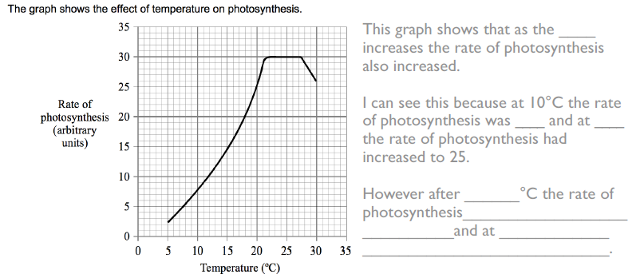

**Dataset 2:**

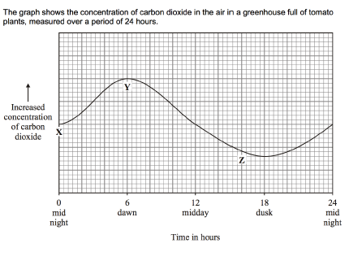

1. Carbon dioxide is used by the tomato plants during photosynthesis. Based on this information and the graph, **identify** at which point (X, Y or Z) the rate of photosynthesis of the tomato plants was the highest.

|  |
| --- |
|  |
|  |
|  |
|  |

1. Based on the graph, **describe** at which time of the day the rate of photosynthesis is the greatest. **Compare** this to the time of day at which the rate of photosynthesis is the lowest.

|  |
| --- |
|  |
|  |
|  |
|  |

**Dataset 3:**

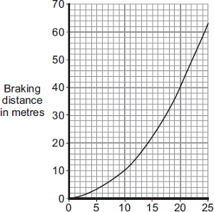

**Speed (m/s)**

**Graph 3:** The effect of speed of a car on braking distance

1. **Describe** the trend shown in graph 3.

|  |
| --- |
|  |
|  |
|  |

1. **Identify** at what speed the car was travelling, to have a braking distance of:
2. 10m
3. 20m
4. 60m
5. **Identify** the braking distance of the car if it is travelling at:
6. 5m/s
7. 14m/s
8. 20m/s

**Dataset 4**

Zara is doing her sprint training. The graphs below show how her distance changes during one run.

1. What does the part of the graph **between X and Y** tell you about Zara?

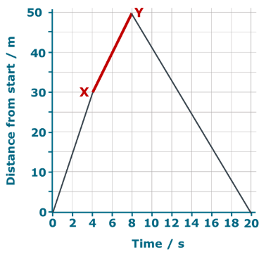Put a tick (✓) in the box next to the best answer.

|  |  |  |
| --- | --- | --- |
| **A** | She climbs a 20m hill |  |
|  |  |  |
| **B** | She runs 50m |  |
|  |  |  |
| **C** | She runs 20m in 8 seconds |  |
|  |  |  |
| **D** | She runs 20m in 4 seconds |  |

1. Where is Zara when she reaches the **point marked Z**?

Put a tick (✓) in the box next to the best answer.

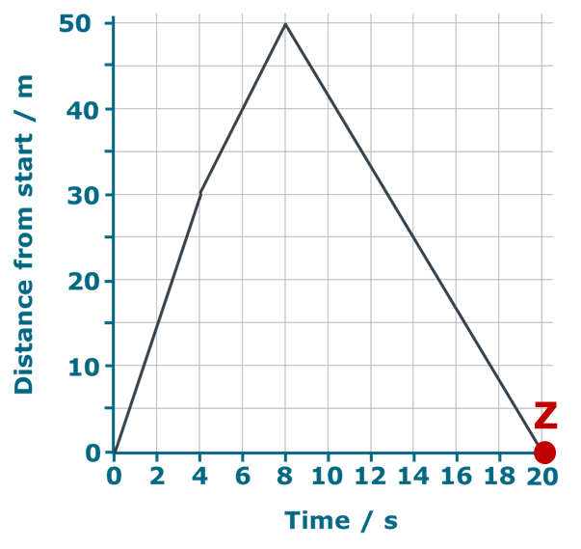

|  |  |  |
| --- | --- | --- |
| **A** | Back to the start |  |
|  |  |  |
| **B** | 50m from the start |  |
|  |  |  |
| **C** | 100m from the start |  |
|  |  |  |
| **D** | You can’t tell |  |

**Dataset 5:**

Mohammed runs fast for 10 seconds. The results are recorded in the graph below.

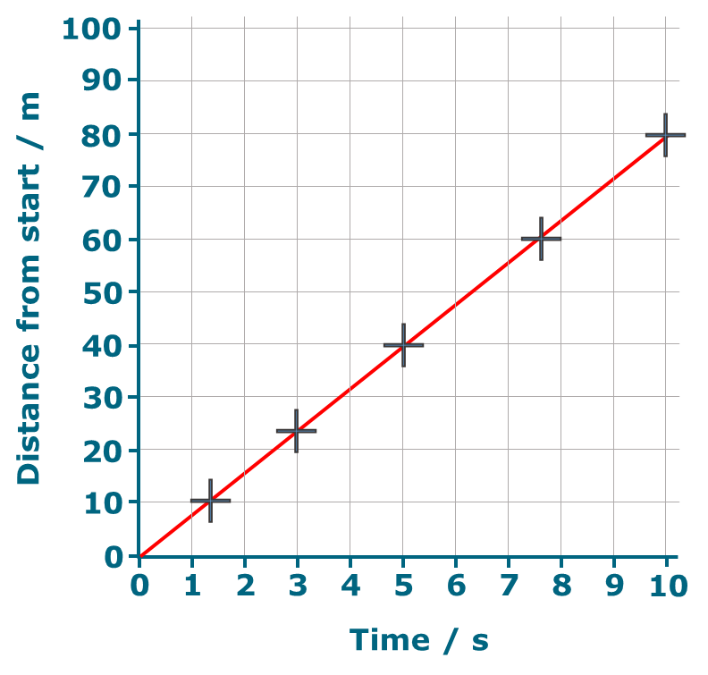

**Graph 4:** The distance run by Mohammed over 10 seconds.

1. Use the graph above to match the correct distance to each time.

5 s

10 s

7.5 s

3 s

6 s

25 m

40 m

46 m

48 m

60 m

23 m

80 m

**Time**

**Distance**

1. Use the graph to match the correct distance to each time.

Rule a line between each time and the correct distance.

70 m

60 m

40 m

30 m

55 m

4 s

5 s

6.9 s

7 s

7.5 s

3.8 s

8.8 s

**Distance**

**Time**

**Dataset 6:**

A nuclear scientist was investigating the properties of a radioisotope, X. The scientist placed a sample of radioactive X near the counter and measured the radiation counts each Monday for 7 weeks, counting the first week as week 0. Her results are shown in the table.

1. Complete the table by writing in the values for the third column.

|  |  |  |  |
| --- | --- | --- | --- |
| Week | Total radiation counts recorded (counts min-1) | Background radiation (counts min-1) | Radiation due to X (counts min-1) |
| 0 | 1031 | 46 |  |
| 1 | 848 | 46 |  |
| 2 | 698 | 46 |  |
| 3 | 566 | 46 |  |
| 4 | 476 | 46 |  |
| 5 | 395 | 46 |  |
| 6 | 328 | 46 |  |

1. On the grid below, plot the results to show the relationship between time and the radiation of X



1. Use your graph to determine the half-life of X.
2. **Predict** the radiation in counts min-1 of X for day 10.
3. **Predict** the radiation in counts min-1 of X for day 38.

**Dataset 7**

The graph below shows the activity of a radioisotope over time.

1. **Identify** the activity of the radioisotope at 25 hours.
2. **Predict** the half-life of the radioisotope.
3. The half-life of radioactive caesium-137 is about 30 years. This means that after 30 years the mass of a sample of caesium-137 will have halved, regardless of its starting mass. If there is a sample of 40 grams of radioactive caesium-137, **calculate** how many years will it take for its mass to decrease to 2.5 grams?
4. Suppose we start with 1 gram of I-131, which has a half-life of 8 days. **Calculate** the amount of I-131 that would remain after 6 half-lives.

**Dataset 8**

A 1cm piece of magnesium ribbon was placed into solutions of different pH’s. The time for the magnesium to dissolve was recorded.

1. Predict the time it would take to dissolve the strip of magnesium if a solution had a pH of 1.5

|  |
| --- |
|  |

1. What is the relationship between pH and the time to dissolve magnesium.

|  |
| --- |
|  |

1. Using your understanding of the pH scale and concentration of H+ ions, explain why the pH 1 solution dissolved the magnesium at a different rate than the pH 4 solution.

|  |
| --- |
|  |
|  |
|  |
|  |